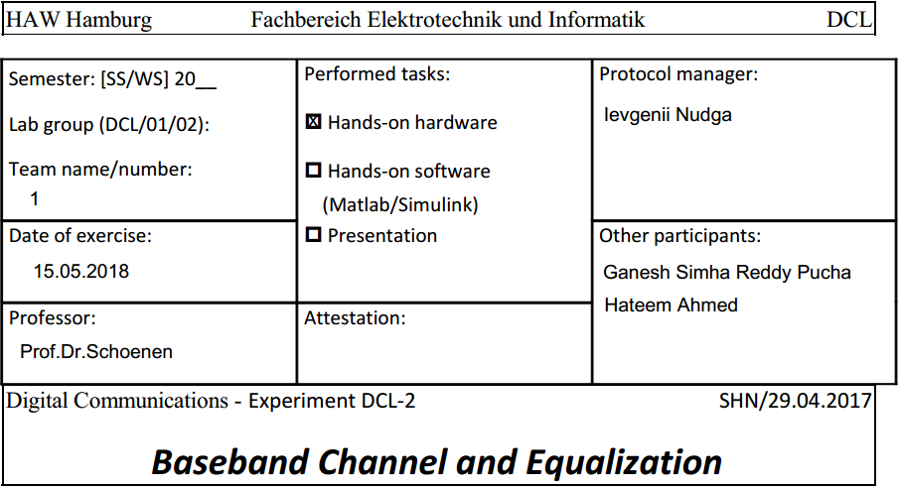

**Introduction**

Digital symbols are transmitted over a channel by means of pulses. Transmission lines (e.g., coaxial or twisted-pair cables) can be considered as low-pass channels. Such channels (linearly) distort the pulses such that inter-symbol interference (ISI) appears. This ISI generally prevents an easy detection by just sampling the received signal. It is therefore important to remove this ISI at the sampling times by proper equalization at the receiver. System theoretic reasoning leads to the 1st Nyquist criterion which is the fundament of equalization and enables dimensioning. There are several approaches for dimensioning. They can be characterized by time-domain or frequency-domain approaches.

The 2nd lab exercise features a transmission system with sender, low-pass channel, and an equalizer system block. The equalizer in this experiment is a finite-pulse response (FIR) filter.

The parameters of the equalizer are to be dimensioned and its function is to be verified by measurements.

The lab exercise consists of three steps:

1. Investigation of the distortion properties of transmission lines of different lengths using a simple model in time and frequency domain.

2. Dimensioning of an FIR equalization filter and analysis of the resulting properties.

3. Manual adjustment of the equalization filter.

The second step in design of the digital base band transmission system is associated with design of channel and channel equalizer. Mostly the task is to analyze the channel and its effects on signal transmission to be able to design a digital transmission with less distortion.

Speaking of transmission with less distortion the main problem is with the channel effect, expecting that the magnitude response of a channel is constant while its phase response is linear. To be precise, a signal is transmitted through a system without distortion, when all frequencies in the signal have the same delay. The frequency dependent delay is described by the group delay. If group delay is constant over frequency, all frequencies in the signal are delayed by the same amount. The channel itself is a cable which can be pictured as an OC circuit and the equalizer to compensate the channel effect can be described by FIR filter.

The block diagram relevant for this experiment are:

Digitizer -> Encoder -> Channel -> Receiver -> Decoder -> Receiver.

In the lab the equalizer is positioned before the channel (on the transmitter side) and not after the channel (receiver). One reason for this is the simpler realization using shift registers.

Since the channel is actually a RC circuit the signal sent to the channel gets corrupted: the pulse spreads out and it interferes with adjacent pulses at sample instants. This unavoidable consequence of channel in communication systems is known as ISI (inter-symbol interference). Thus the equalizer’s main role is to remove this effect at sample points. Equalizer filter consists of delay line with T-second taps where T is equals to the symbol duration and coefficients that weight the input signal to achieve no interference between samples at sample points.

There is a trade between the selection of amplitude and ISI value. It is possible to choose the amplitude in the range of symbol duration. After adjusting the coefficients, the transmission can be evaluated by the eye diagram. The latter is created by taking the time domain signal and overlapping the traces for a certain number of symbols. The open part of diagram represents the time that we can safely sample the signal.

By the theory of transmission lines an infinitesimally small piece of such a line can be modeled by a series correction of a conductance and a capacity element. For low frequencies this can further be simplified by omitting the inductivity and any resistance parallel to the capacitor. Another simplification is to assume a finite length line instead of an infinitesimally small piece. These simplifications result in the model that is used in this experiment. It consists of a series connection of simple RC elements. The number (order) of these elements can be adjusted between one and eight. The more elements are combined the more length of the transmission is modeled. It’s not a good approximation of a real transmission line, but sufficient for emulating the distortion effects here.

* 1. **Investigation the properties of the low-pass channel**

1. Preparation is shown in the figure 1 below. For n = 2 the poles of the transfer function are calculated by circuit analysis, as well as the transfer function of this model.

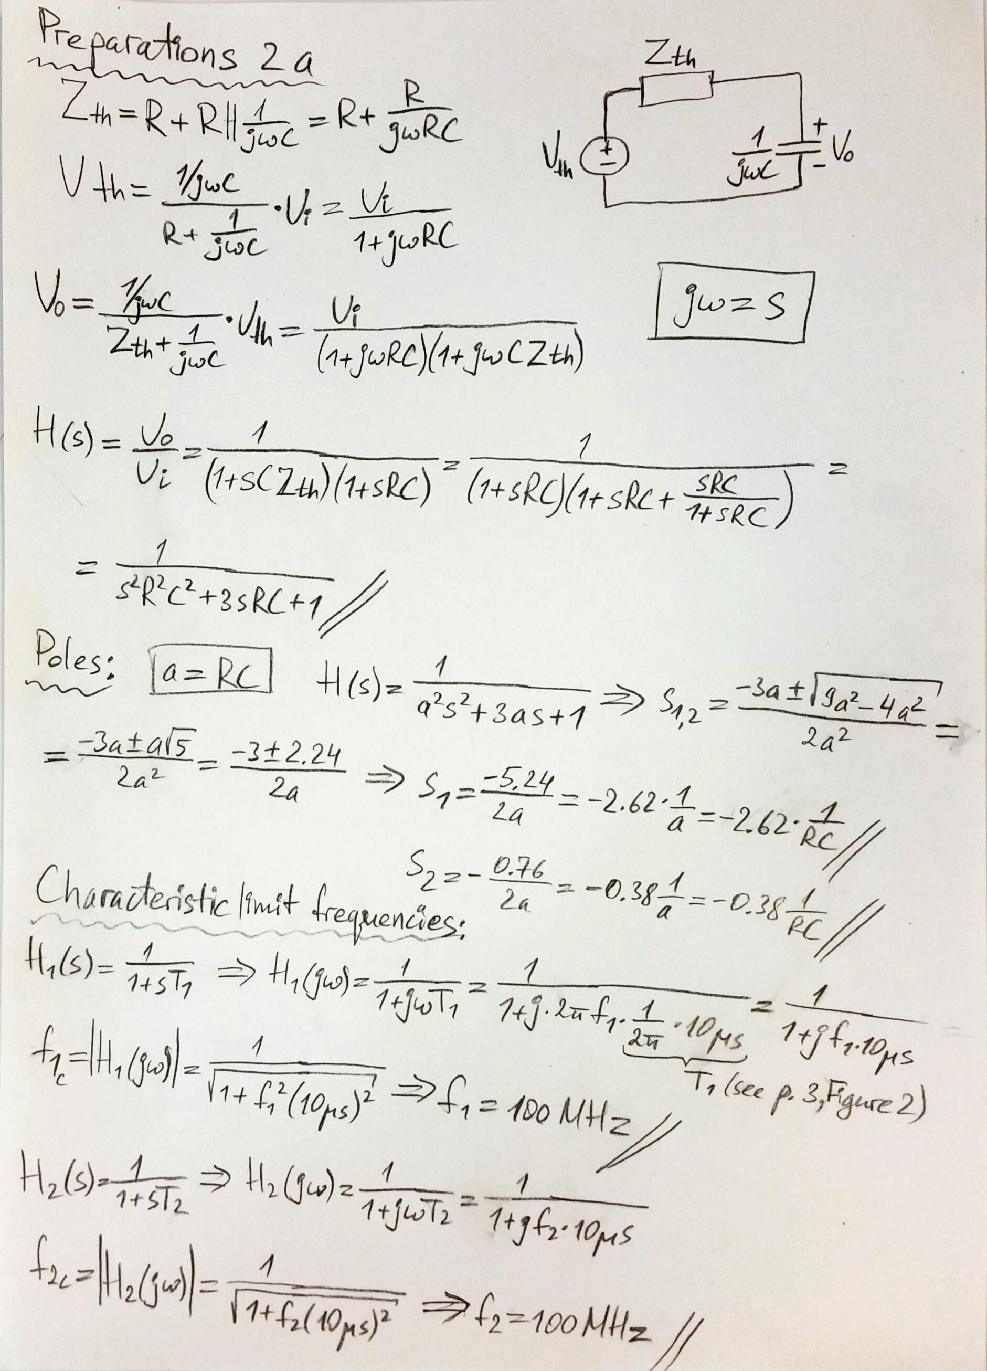

**Fig.1 Calculations for preparation**

1. In this step the amplitude response is measured for such channel settings: the order n=2 and n=5

Measurement devices: Network analyzer, channel model box, oscilloscope.

Measurement parameters: Frequency range 0 … 60 kHz.

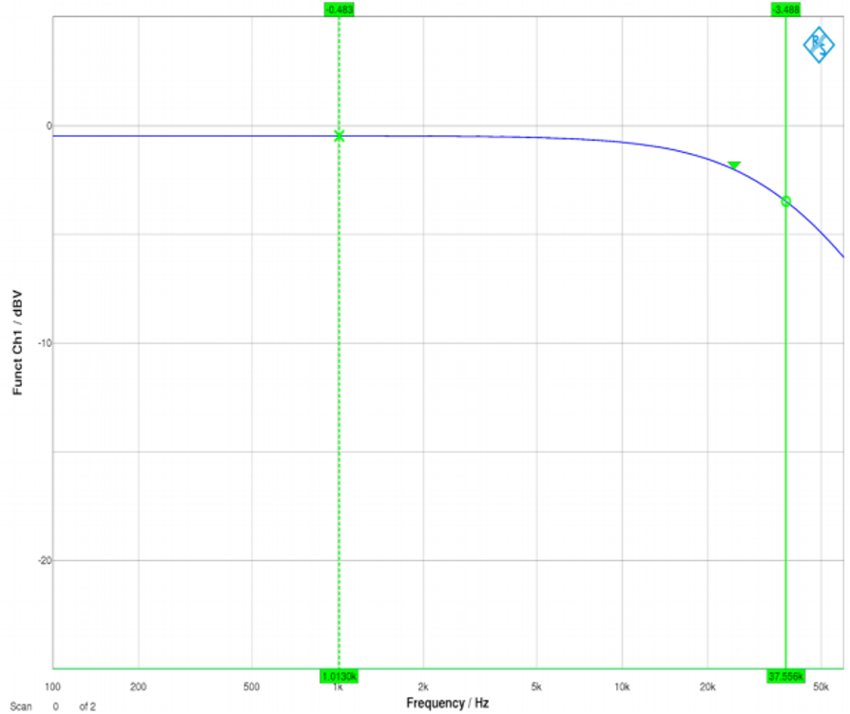

**Fig.2 the amplitude response with low-pass channel model of order n=2**

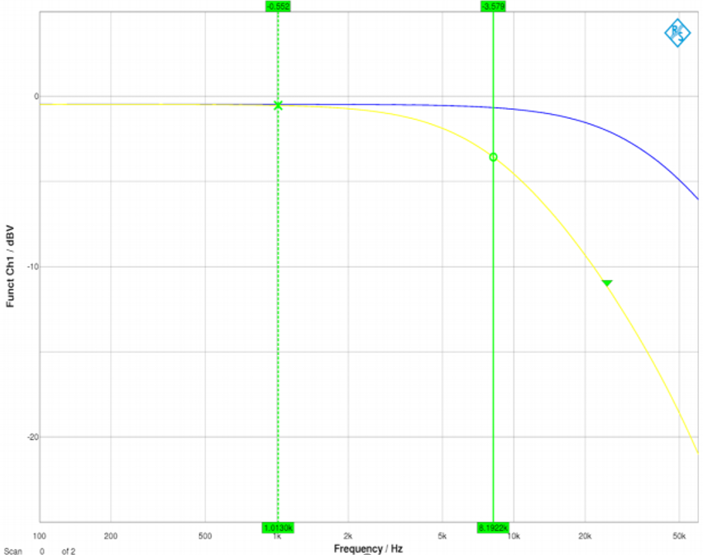

**Fig.3 the amplitude response with low-pass channel model of order n=5**

* 1. **Measurement of the response of the two channel models for an input rect(t/T0) pulse of width T0.**

A bit generator generates a bit stream of 2 bytes with bit clock of 64 kHz. To calculate the equalizer coefficients, a single ‘1’ bit followed by fifteen ‘0’s is transmitted through the system. The output of the channel is connected to the scope, from where the equalizer coefficients are measured as sample points.

1. For preparation calculations see the Fig. 4 below. For n = 2 the response of the channel model for a rect(t/T0) pulse of width T0=1/f0 is calculated using transform tables.

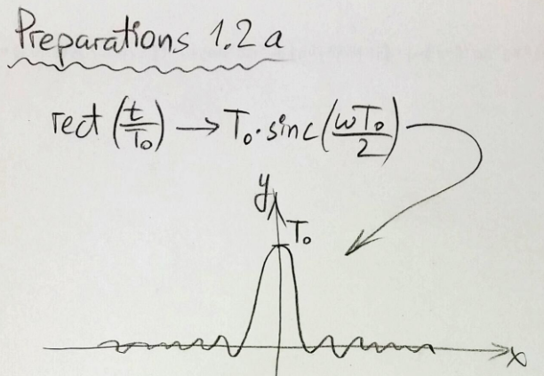

**Fig.4 Preparation calculations**

1. Parameters for experiment:

Word generator: Bit sequence “1000.0000.0000.0000”,

clock intern - frequency f0 = 64 kHz

Adjustment procedure: The coefficient a0 is set such that the pulse amplitude at the filter output is maximum (Up = 7,5 V). Then the other coefficients an for n > 0 are adjusted to provide a constant offset voltage at the output (see Fig. 5,6).

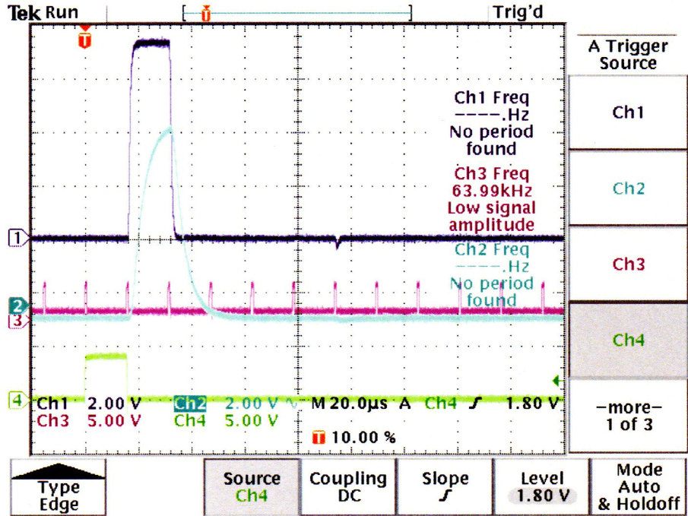

**Fig.5 The output after calibration of the equalizer coefficients to be neutral with low pass channel model of order n=2**

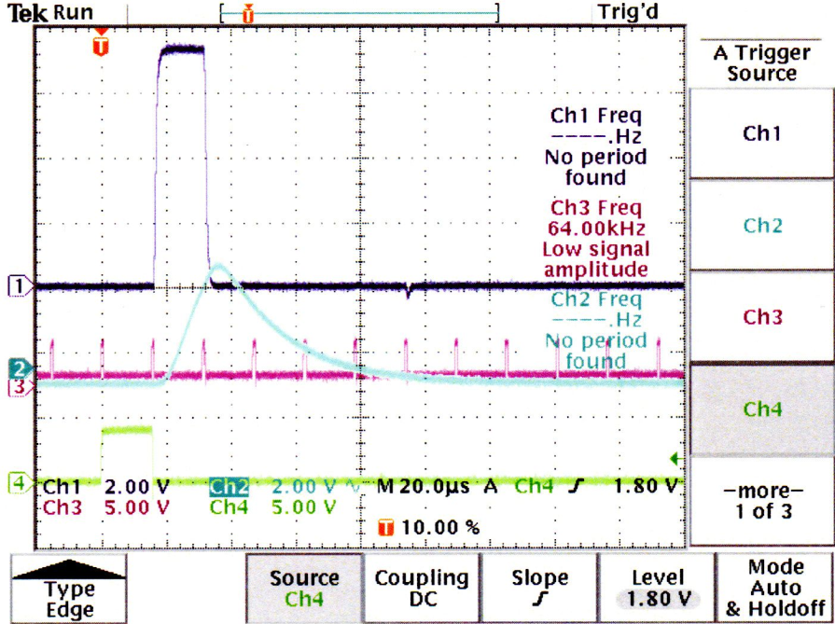

**Fig.6 The output after calibration of the equalizer coefficients to be neutral with low pass channel model of order n=5**

* 1. **Measurement of the** **response of the channel model box with the input of a random bit sequence generated by the pseudo-noise generator (PNG)**

1. Devices: Pseudo noise generator (PNG), equalizer filter, channel model box, oscilloscope, printer or web browser via HTTP/TCP/IP access.
2. Circuitry: As in the experiment before, but just replace the word generator by the PNG.
3. Parameters:

Pseudo noise generator: Period 28-1 (every 28-1 = 255 clocks the sync is high), clock intern - frequency f0 = 64 kHz.

Equalizer: unchanged.

Low-pass channel model: Order n = 2 (Switch 2-T1 up, all others down)

1. Measurements:

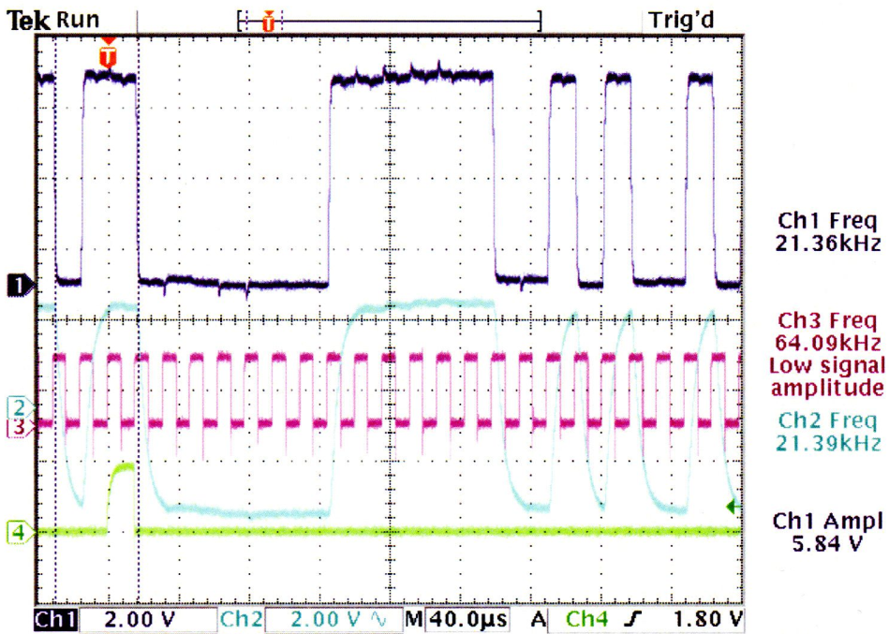

**Fig.7 The channel output with LP channel model of order n=2**

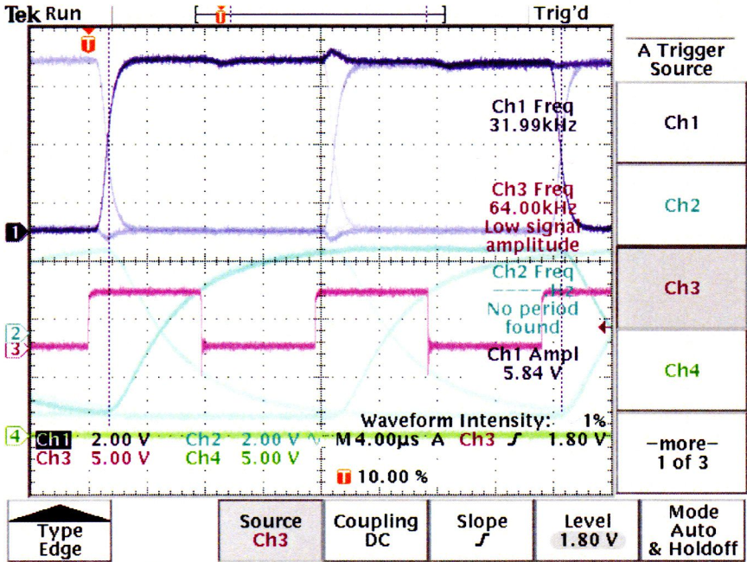

**Fig.8 The eye-pattern diagram for channel output with LP channel model of order n=2**

1. The channel filter order is changed to n=5, thus the measurements changed this way:

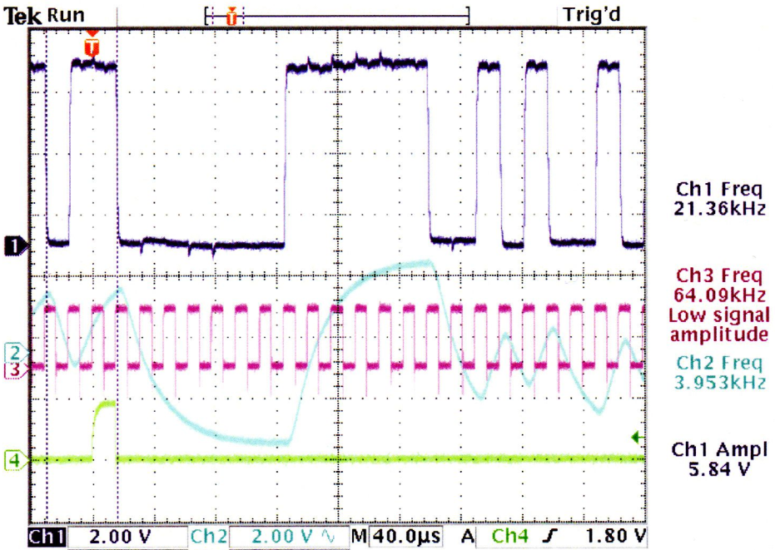

**Fig.9 The channel output with LP channel model of order n=5**

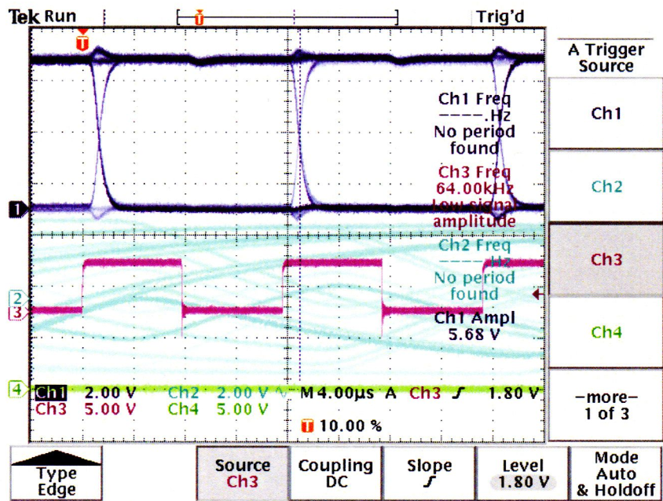

**Fig.10 The eye-pattern diagram for channel output with LP channel model of order n=5**

1. **Equalization using an FIR filter**

Equalization aims at achieving samples of value zero for the effective pulse response hg (t)= hFK (t)*hCH(t) (*=convolution) at all other instances outside of the main sample time ts, thus compensating for the ISI caused by channel pulse response in time domain. A Zero at hg(ts=2T0) can be realized by scaling the (delayed) eq-filter pulse response hFK(ts-T0) at time 2T0 with a factor a1 and subtracting the whole function from the channel pulse response: a0·hFK (t). The symbol itself is sampled at time ts=T0. The next Zero must be realized at 2T0 after the main sampling instance, i.e. at ts=3T0 in the figure. Again, this is done by scaling hFK(t-2T0) with a suitable factor a2 before the superposition on top of hg1(t). This procedure must be repeated for each multiple of T0 such that the remaining pulse hgn(t) is free of significant ISI.

To achieve an SNR as large as possible, the received symbol must be sampled at the maximum of receive impulse (usually requires timing synchronization). With long transmission lines the distortions can lead to a situation where the impulse maximum appears at a larger distance than T0 from the beginning of the pulse. For practical purposes the sampling instance is put to a point where the difference (D) between symbol value and the leakage value is at maximum. In order to achieve a maximum opening in the eye-pattern, a small remaining ISI can be tolerated.

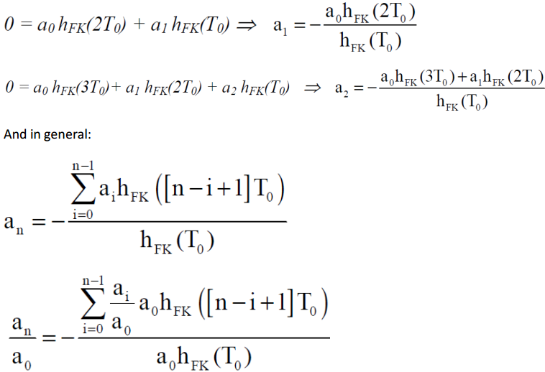

**Fig.11 Calculations for task 3.1**

* 1. **Equalization using an FIR filter**

1. The devices used for this measurement are: Word generator, channel model box, equalizer, oscilloscope, printer. The measurement circuit consists of word generator connected to channel input.
2. Parameters: Word generator bit sequence 1000.0000.0000.0000,

clock intern - frequency f0 = 64 kHz.

Equalizer in default condition (dirac output response).

LP channel model box: Order n = 5 (switch 5-T1 up, all others down)

1. Measurements:

The coefficients are calculated from the measured voltage and according to formulas from Fig.11. The results are shown in the table below

|  |  |  |
| --- | --- | --- |
| Measured voltage, V | hFK(t) | Coefficients |
| 2.38 |  | a0 = 2.38 |
| 1.92 | hFK(T0) = 1.92/2.38 = 0.807 | a1 = -a0* hFK(2T0)/ hFK(T0) = -1.06 |
| 0.86 | hFK(2T0) = 0.86/2.38 = 0.361 | a2 = -(a0* hFK(3T0) + a1* hFK(2T0)/ hFK(T0) = -0.9696 |
| 0.40 | hFK(3T0) = 0.40/2.38 = 0.168 |  |

The coefficients are adjusted step by step using the potentiometers, beginning with a1. The results are in Fig.12 and the corresponding eye diagram can be seen on Fig.13.

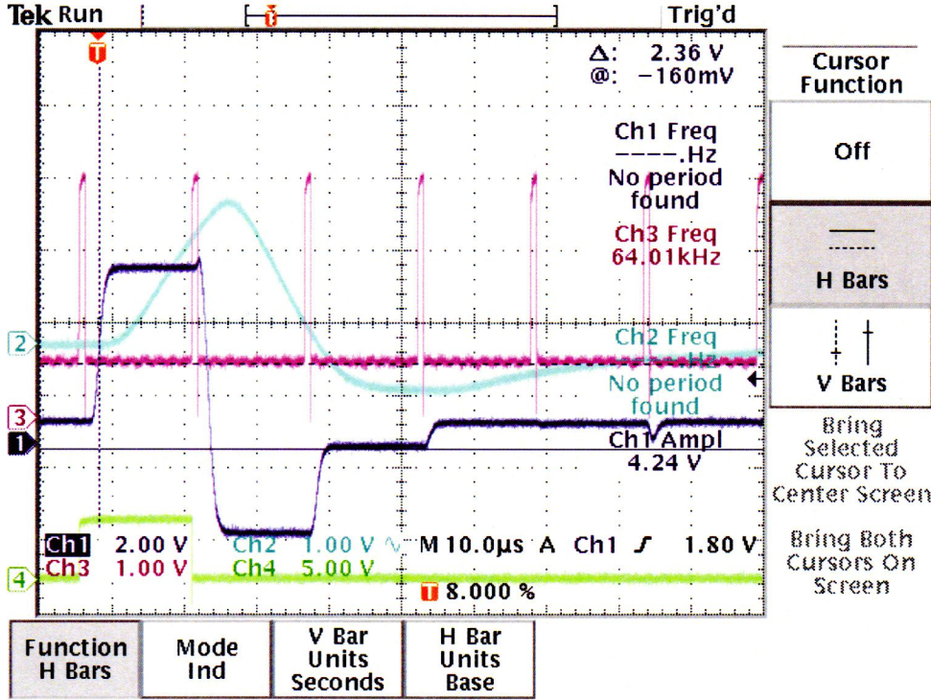

**Fig.12 The equalizer output with calculated coefficients**

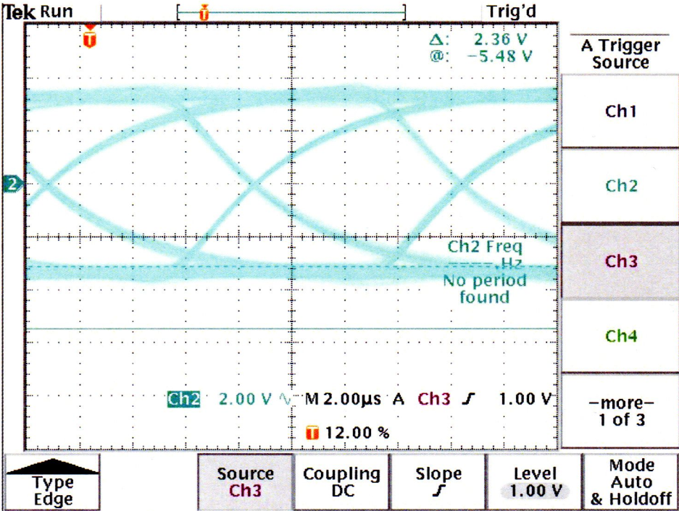

**Fig.13 The eye diagram for output with calculated coefficients**

1. **Manual (experimental) adjustment of the equalizer**

The available equalizer didn’t have an option for adjusting coefficients to the values obtained in the previous step. Thus they were to be adjusted manually. Parameters: Word generator: bit sequence 1000.0000.0000.0000, clock intern - frequency f0 = 64 kHz.

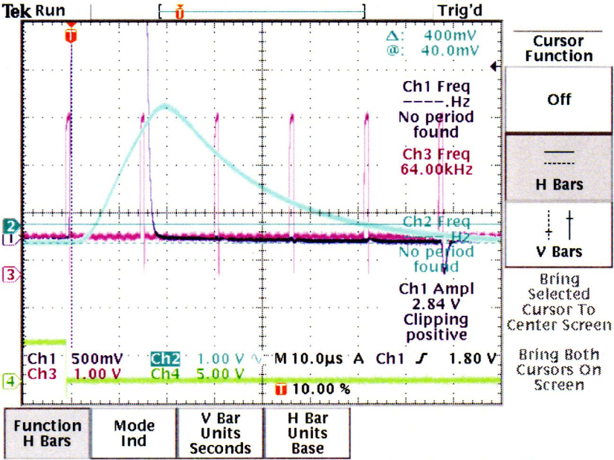

**Fig.14 The equalizer output with manually adjusted coefficients**